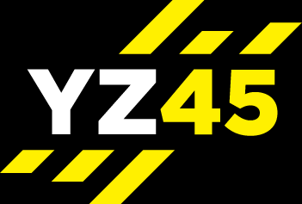
YZ45 CIRCUITS
HYBRID – AMRAP = 39 MIN
(1:30 min blocks – complete 2 circuits)
Warm up 3-5 mins
Cardio
40 sec rest period
Upper Body
40 sec rest period
Abs / Core
40 sec rest period
Compound
40 sec rest period
Cardio
40 sec rest period
Lower Body
40 sec rest period
Abs / Core
40 sec rest period
Compound
40 sec rest period
Plyometric
1 min recovery after 1 circuit
Cool down & stretch 3-5 mins

