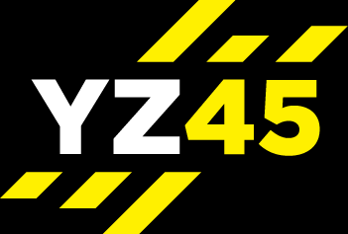
YZ45 CIRCUITS
STRENGTH – AMRAP = 39 MIN
(1:30 min blocks – complete 2 circuits)
Warm up 3-5 mins
Upper Body
40 sec rest period
Lower Body
40 sec rest period
Abs
40 sec rest period
Core
40 sec rest period
Upper Body
40 sec rest period
Lower Body
40 sec rest period
Abs
40 sec rest period
Core
40 sec rest period
Plyometric
1 min recovery after 1 circuit
Cool down & stretch 3-5 mins

