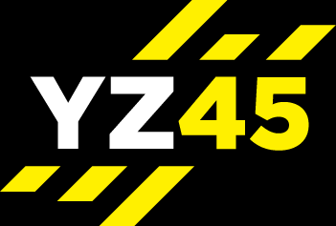

YZ45 CONTRAST
AMRAP = 38 MIN
Complete 1 full circuit of each - 40 sec each / 50 sec each / 40 sec / 50 sec
Warm up 3-5 mins
Type | Exercise |  | 1  40 sec | 2  50 sec | 3  40 sec | 4  50 sec
Cardio
25 sec rest period
Upper Body
25 sec rest period
Lower Body
25 sec rest period
Core
25 sec rest period
Cardio
25 sec rest period
Upper Body
25 sec rest period
Lower Body
25 sec rest period
Abs
1 min recovery after each complete circuit
Cool down & stretch 3-5 mins

