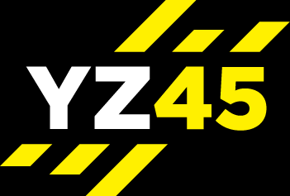
YZ45 PYRAMID
Can you complete the pyramid? - 30 sec work /25 sec rest – AMRAP = 39 MIN – 60 sec rest at the mid-point - RED
The Pyramid – ALWAYS start at the bottom - work to the top

NO | EXERCISE | WORK  secs | REST  secs | ROUNDS
 |  |  |  | 1 | 2 | 3 | 4 | 5 | 6 | 7 |  | 8 | 9 | 10 | 11 | 12
WARM UP 3-5 mins
6 |  | 30 | 25
5 |  | 30 | 25
4 |  | 30 | 25
3 |  | 30 | 25
2 |  | 30 | 25
1 |  | 30 | 25
COOLDOWN & STRETCH 3-5 mins
TIMING SPLITS |  |  |  | 19.10 MINS |  |  |  |  |  |  | 19.10 MINS

