Welcome to YZ45 **2022** newsletter

Keep pushing forwards to achieve your goals!

**CLUBS HIGH ACHIEVERS**

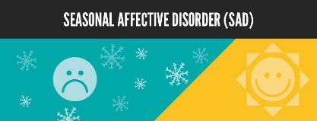

**Mexican steak & brown rice bowl**

While too much red meat can take a toll on your heart and your waistline, in moderation it can provide a ton of protein and vitamin B12, which is needed for red blood cell health.

PREP - 10 m / COOK - 1 h / TOTAL - 1h 10m

**NUTRITION INFORMATION**

598 CALORIES PER SERVING

Serving Size: 1 brown rice bowl

|  |  |
| --- | --- |
| % DV* | |
| * Total Fat 16g | 23% |
| * Saturated Fat 3g |  |
| * Cholesterol 1mg | 0% |
| * Sodium 434mg | 18% |
| * Carbohydrates 82g | 40% |
| * Dietary Fibre 23g |  |
| * Sugars 6g |  |
| * Protein 32g | 21% |
| * The % Daily Value (DV) tells you how much a nutrient in a serving of food contributes to a daily diet. 2,000 calories a day is used for general nutrition advice. | |

**INGREDIENTS -** SERVES 1

½ cup Brown Rice / 1 cup cooked black beans / 2 oz Sirloin Tip Steak Thin / 2 tbsp Non-fat Yogurt, Plain / ½ cup Red Leaf Lettuce / ½ fruit without skin and seed Avocados, raw, California / 1 medium whole tomato / ½ yields lime juice / 1 ½ tbsp Pickled Carrots Sliced / 1 ½ tbsp Jalapenos, Pickled Slices

**DIRECTIONS**

1. Marinate 3 ounces of steak in a small container with enough lemon juice to cover for a half hour.
2. Cook and season 1/2 cup of rice and 1 cup of beans separately.
3. Place the rice in the bowl.
4. Grill the steak for 12 minutes, then slice thin and add to the rice.
5. Add 2 tablespoons of yogurt, thinly sliced red leaf lettuce from 2 leaves, 1 chopped tomato and 1 sliced avocado half.
6. Sprinkle the lime juice over all the ingredients, and garnish with 3 pickled carrot and jalapeño slices.

**Seasonal Affective Disorder (SAD)**

SAD is a form of depression that comes and goes with the season. As the sun sets and stays down, so does a person’s mood. Symptoms of SAD can include:

* Feelings Of Sadness Or Hopelessness
* Fatigue And A Tendency To Oversleep
* Change In Appetite Leading To Weight Gain
* Loss Of Energy
* Irritability And Increased Sensitivity
* Difficulty Concentrating

**Why Exercise With Seasonal Affective Disorder?**

Exercise is beneficial for anyone who is suffering from depression as exercise releases endorphins, which are hormones that reduce pain and increase feelings of well-being. In addition, exercise increases your metabolism, which helps improve your energy levels. Plus, the fatigue from well-used muscles is a healthier type of fatigue than that of depression. Other benefits include:

* Increased Self-Esteem
* Improved Sleep
* Reduced Anxiety

You may not feel like training alone which is why YZ45 is there to help! You will meet new people, make new friends and become part of a great team!

**Training / Info**

**Healthy Recipe / Nutrition**

Please be careful if you have any allergies.

**Club Promotions / Challenges**

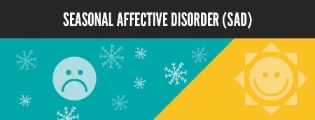

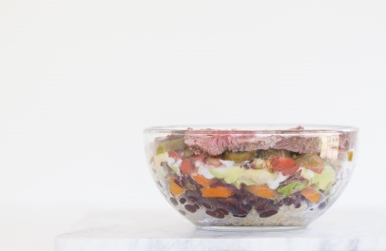

**Club Information**