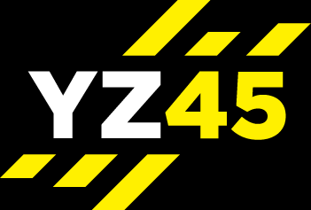
REVITALISE

MOBILITY – STRETCH - RELAX = 30 MIN

Mobility
Total Time – 10 Mins
Stretch
Total Time – 17 Mins
(Either 2 X 30 Sec Or 1 Min)
Relaxation | Lay On Back – Deep Breathing, Relaxing – Focusing On Clearing The Mind
Total Time 3-5 Mins

