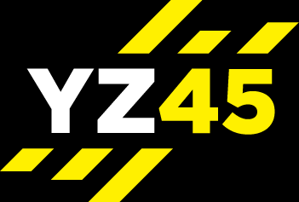
REVITALISE

MOBILITY – STRETCH - RELAX = 30 MIN

Mobility | - Ankle Rotations – 30 Sec Each Direction – Both Sides  - Leg Step Overs Alternating Sides – 30 Sec Each Direction  - Hip Rotations – 30 Sec Each Direction  - Torso Rotations Alternating - 30 Sec  - Arm Circles – Both At The Same Time - 30 Sec Each Direction  - Lateral Hold With Alternating Hand Rotations (Palms Up / Down) – 30 Sec  - Lateral Hold – Elbows At 90 Degrees Alternating Rotations (Palms Forward / Palms Down) – 30 Sec  - Shoulder Shrug Rotations – 30 Sec Each Direction  - Head Twists Alternating – 30 Sec  - Wrist Rotations – 30 Sec Each Direction
Total Time – 10 Mins
Stretch | - Standing Forearm Stretch X 2  - Standing Neck Stretch X 2  - Standing Tricep Stretch X 2  - Standing Arms Stretched Up X 1  - Standing Arm Across Body Shoulder Stretch X 2  - Standing Upper Back Stretch X 1  - Standing Chest Stretch X 1  - Kneeling Hip Flexor Stretch X 2  - Front Lying Cobra Stretch X 1  - Kneeling Cat / Camel Stretch X 1  - Kneeling Bird Dog X 1  - Childs Pose X 1  - Front Lying Quad Stretch X 2  - Back Lying Dead-Bug X 1  - Back Lying Double Knee Hug Back Stretch X 1  - Back Lying Glute Stretch X 2  - Lying Hamstring Stretch X 2
Total Time – 17 Mins
(Either 2 X 30 Sec Or 1 Min)
Relaxation | Lay On Back – Deep Breathing, Relaxing – Focusing On Clearing The Mind
Total Time 3-5 Mins

